**LINQ to Objects Exercises**

For online Book Shoppe, the information needs to be maintained about the books that are currently available.

**2.1.1 Objective**

Perform queries on the Books collection using LINQ.

**2.1.2 Problem Statement**

Create a Book collection containing following fields and data: 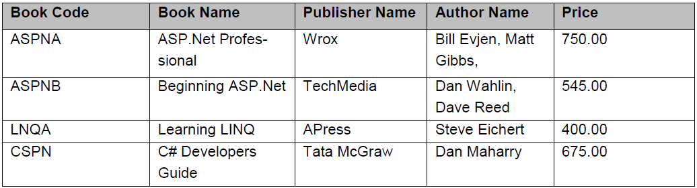

Provide the following options

1. Filter criteria to display book information based on the user input BookCode. When the user entered the **BookCode** value, the matching book row information should be displayed.

2. Display the books falling between some price ranges.